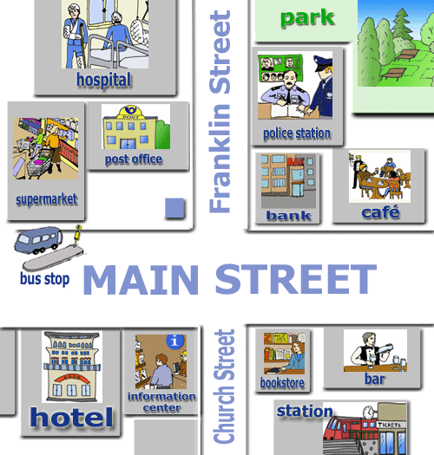
Prohlédni si obrázek a
doplň názvy míst.

1. It is next to the police station. ..........................................
2. It is opposite the bar. ............................................
3. It is next to the hospital. ............................................
4. It is opposite the bank. ............................................
5. It is next to the information centre. ............................................
6. It is next to the café. .............................................
7. It is opposite the hotel. .............................................
8. It is opposite the supermarket. ............................................

Názvy míst ve městě si i s výslovností procvičuj a otestuj na níže uvedených odkazech.
https://www.helpforenglish.cz/article/2008080202-in-the-town-slovni-zasoba slovíčka
https://www.helpforenglish.cz/vocabulary-coach/exercise/124 on-line test zeslovíček

Opatrujte se :-)

